ECS TASK
- Setup a highly available ecs cluster with load balancer and dynamic port mappinig.
NOTE:
Your cluster should maintain atleast 6 tasks at any point of time and should be highly available across multiple AZ’s.
Use the below image from deployment:
Sabair0509/hiring-app:works

Step 1 – Create an ECS cluster (EC2 launch type).
- Go to EC2 console → clusters → create cluster.
- Choose EC2 Linux + Networking.
- Enter cluster Details.
- Cluster name: hiring-app-cluster
- Instance type: t3.medium (or larger)
- Number of instances: 3 minimum (for HA)
- Key pair: select one for SSH access
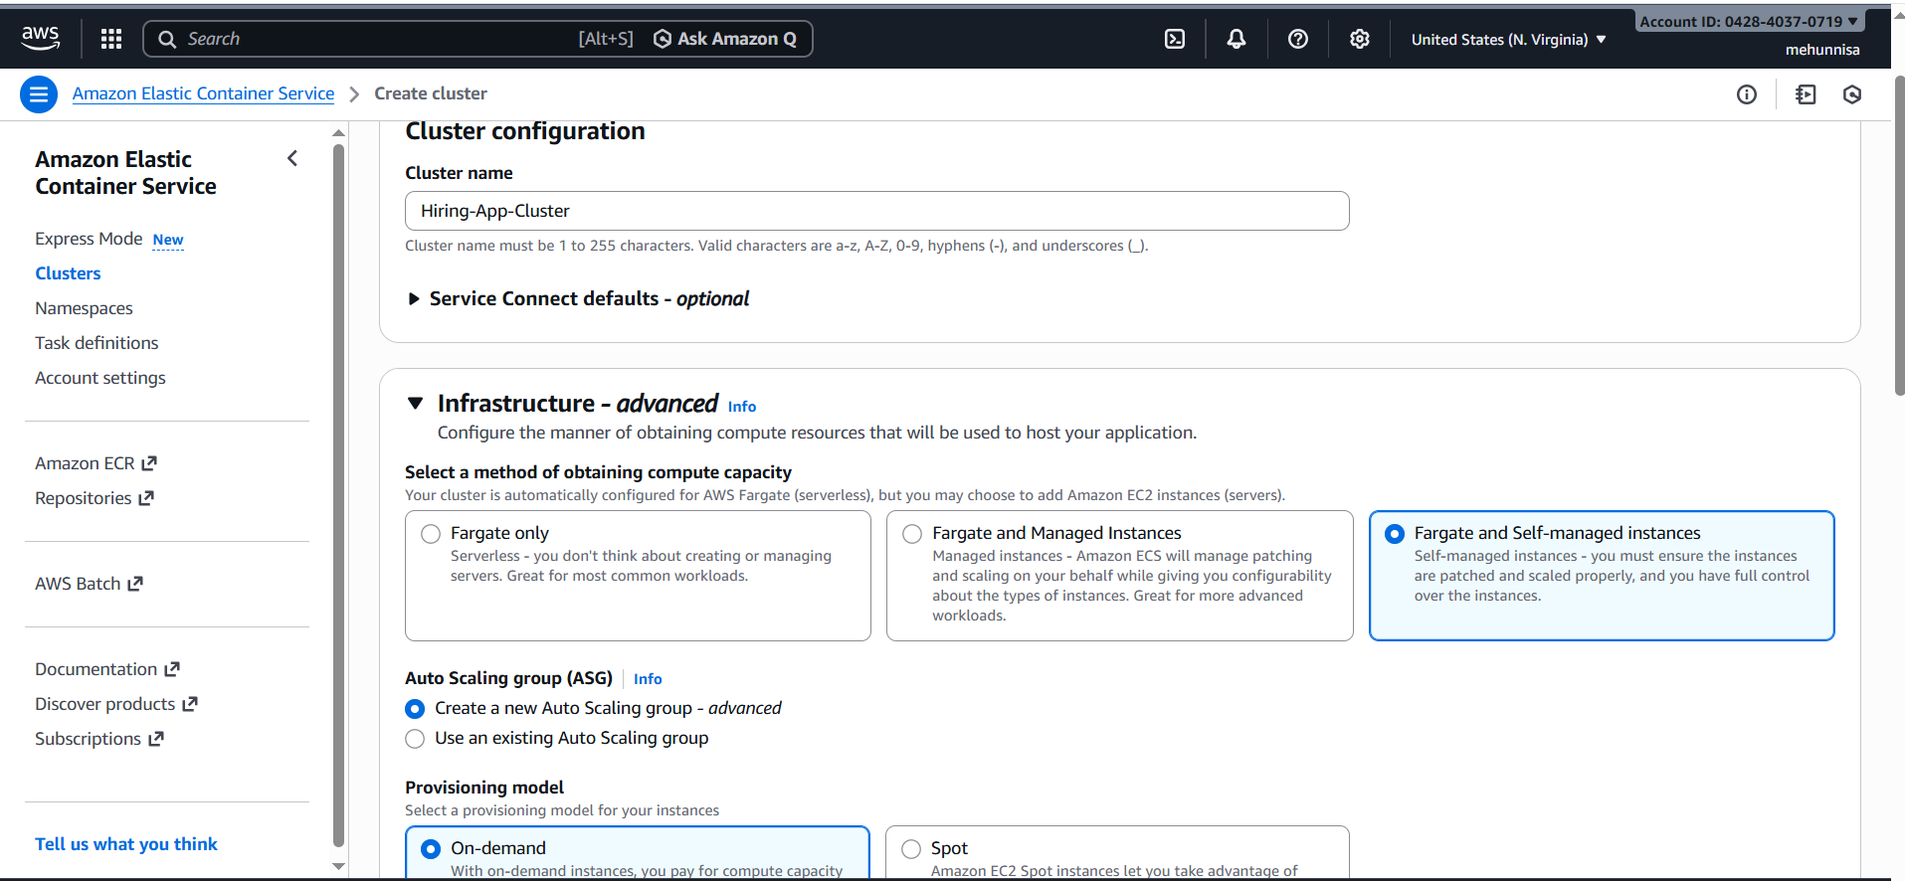
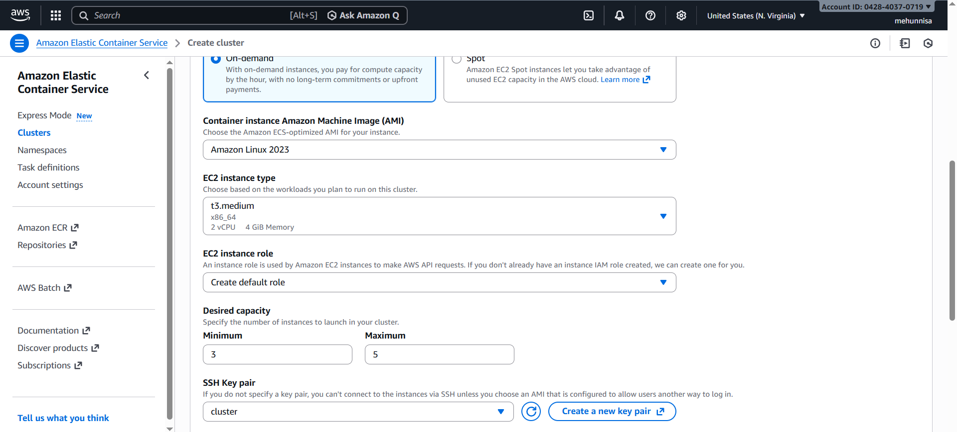
4. Networking:
e. VPC : hiring-app-vpc
f. Subnets: Select atleast 2 public subnets(for high )
g. Security group: ecs-instance-sg
5. IAM Role:
a. instance role: ecsinstancerole
i. if it doesn’t exist create a new role with
AmazonEC2ContainerServiceforEC2Role Policy
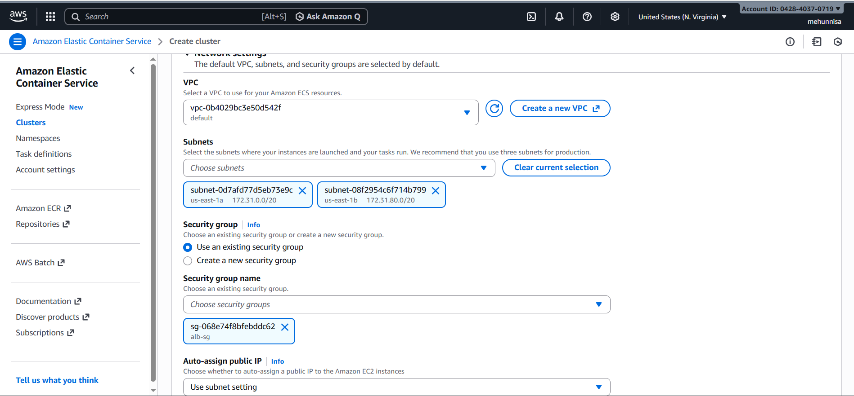

- Click create cluster and wait for EC2 instances to register in ECS.
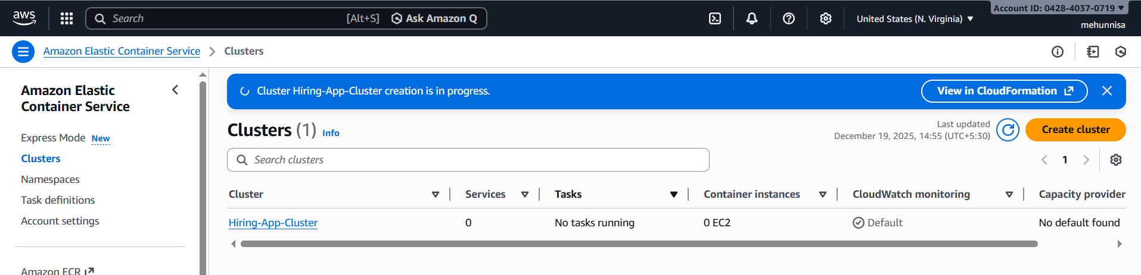Step 2 – create a task definition (Dynamic port mapping)
- Go to ECS → Task definitions → create new task definition → EC2
- Configure task definition:
- Task Definition name: hiring-app-task
- Task Execution role: ecsTaskExecutionRole
- Network mode: bridge

- Add a container:
- Containername: hiring-app
- Image: sabair0509/hiring-app:works
- Port mapping:
i. Container port: 80
ii. Host port: 0 (dynamic port mapping)
- Click Add, then create Task Definition.
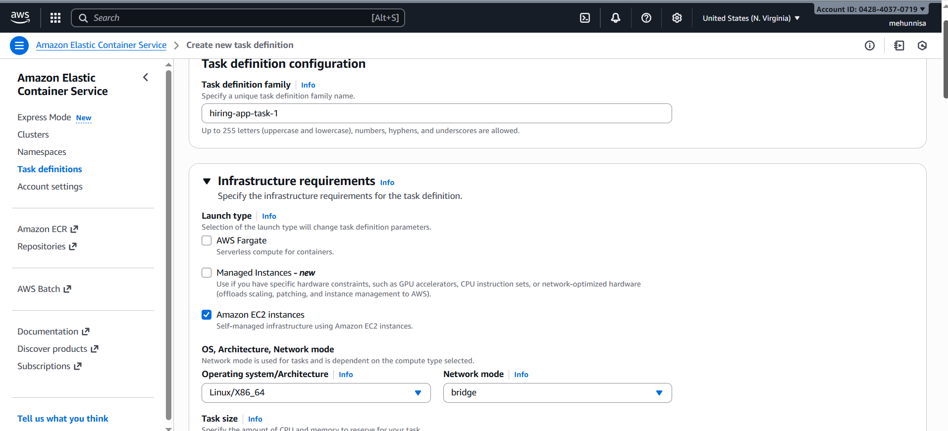
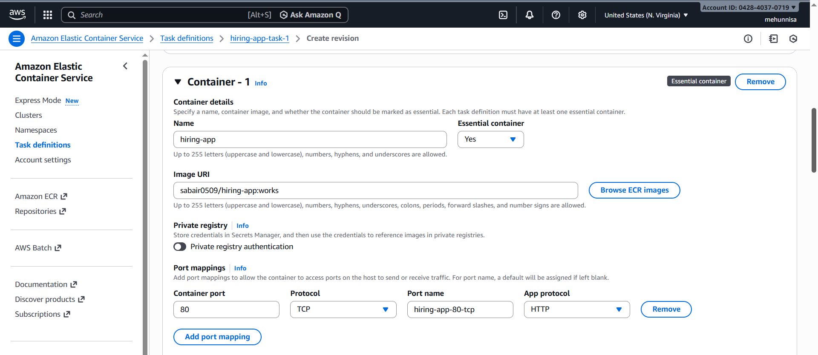
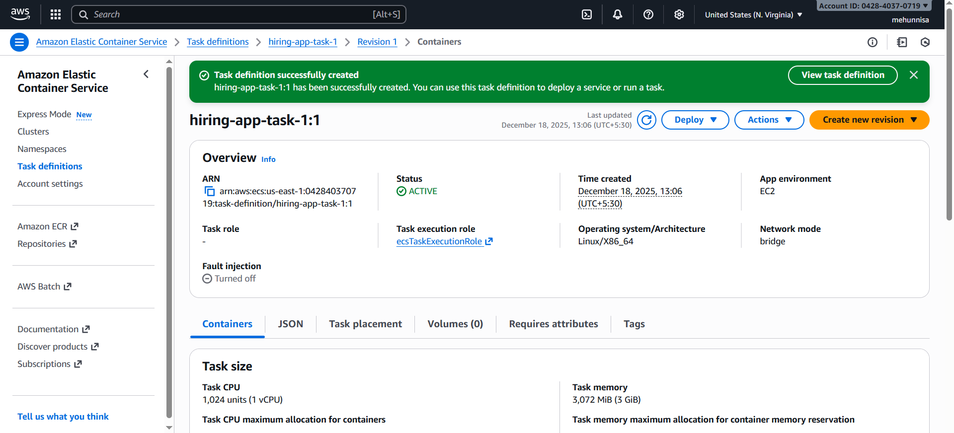Step 3 – create Application Load Balancer (ALB)
- Go to EC2 → Load Balancers → create load balancer → Application load balancer.
- Configure ALB:
- Name: Hiring-App-ALB
- Scheme: internet-facing
- IP type: IPv4
- Listener : HTTP:80
- vpc: hiring-app-vpc
- Availability Zones: select atleast 2 public subnets
- Security Group: alb-sg
- Click next to create the ALB
- Click next to create the ALB.
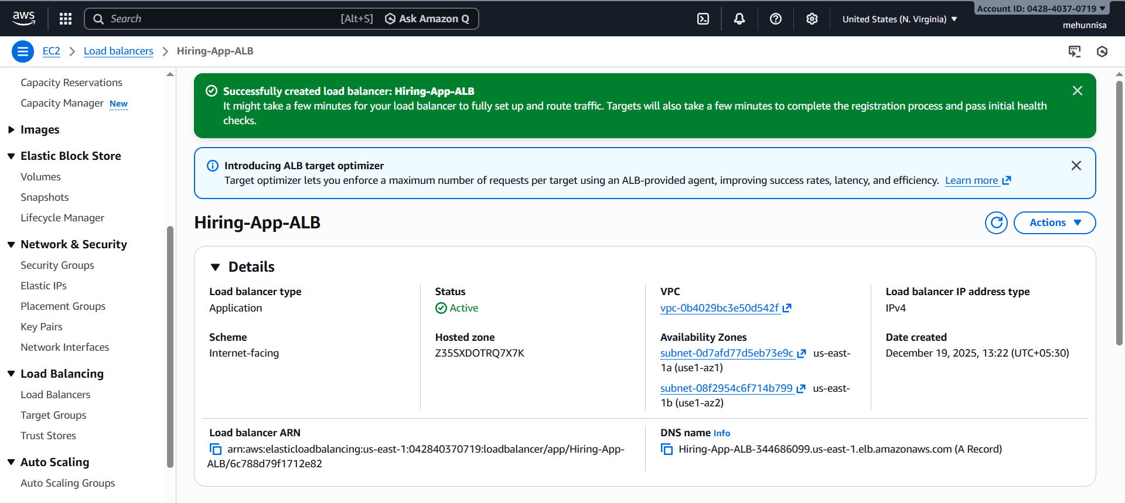
Create target group
- Target group details:
- Name: Hiring-App-TG
- Target type: Instance
- Protocol/port: HTTP / 80
- VPC: hiring-app-vpc
- Health check path: /
- Click create Target Group.
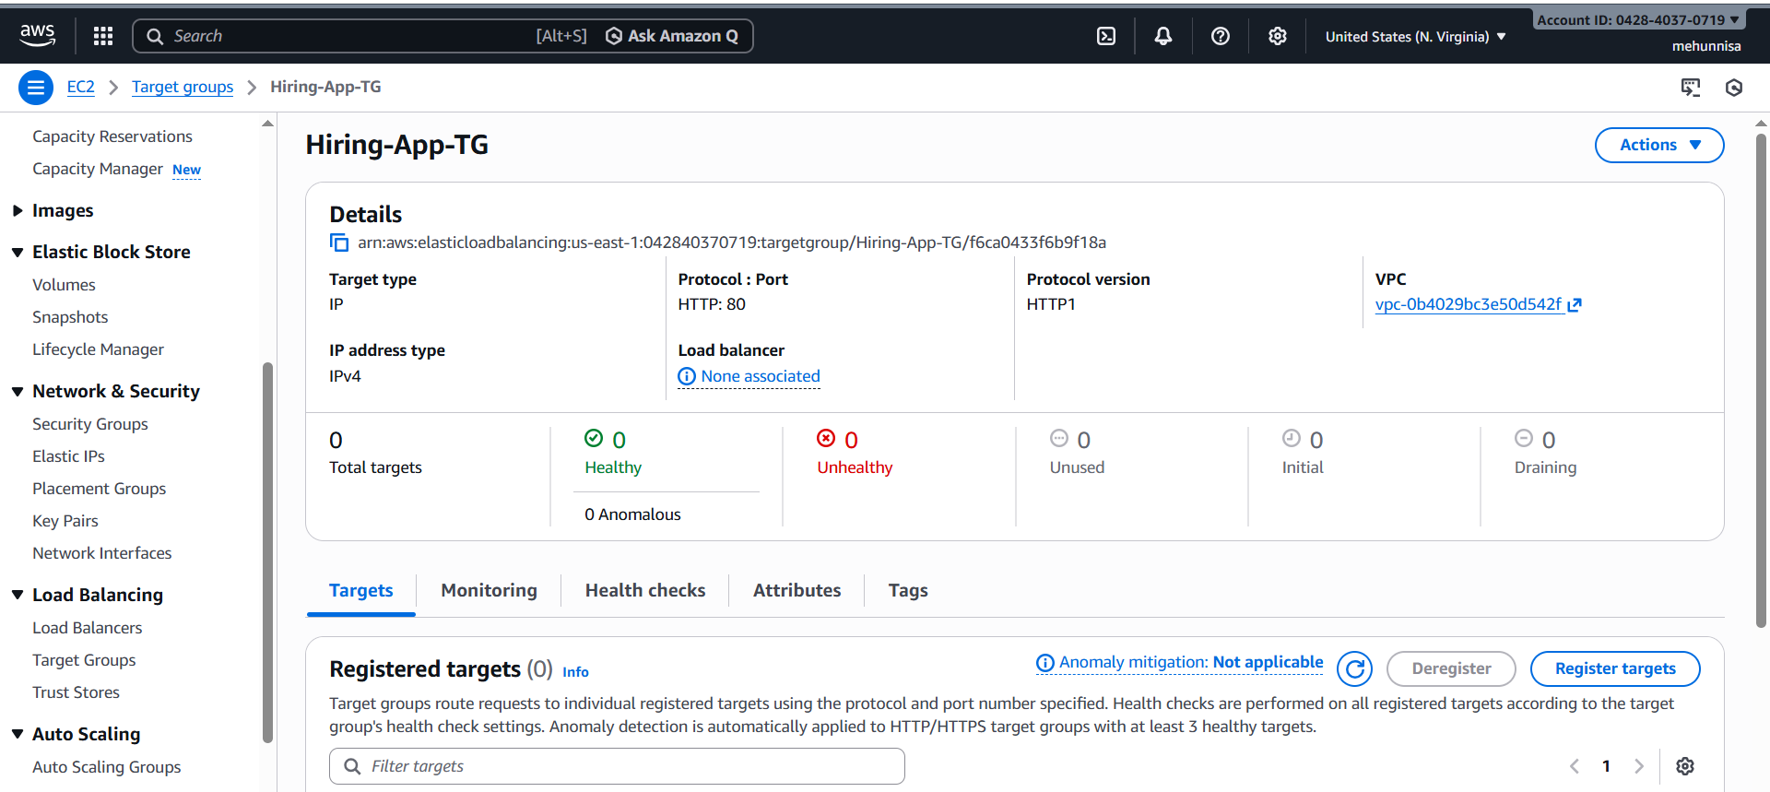
Step 4 – create ECS service and attach ALB
- Go to ECS → clusters → hiring-app-cluster → services → create.
- Configure service:
- Launch type: EC2
- Task definition: latest version of hiring-app-task
- Service name: hiring-app-service
- Desired tasks: 6
- Deployment type: Rolling update
- Load balancing:
- Choose application load balancer.
- Add container to ALB:
i. container: hiring-app:80
ii. target group: hiring-app-tg
iii. health check: /
- Optional auto scaling:
- Minimum: 6 ; maximun: 12
- Placement strategy:
- Spread → attribute:ecs.availability-zone
- Click create service.
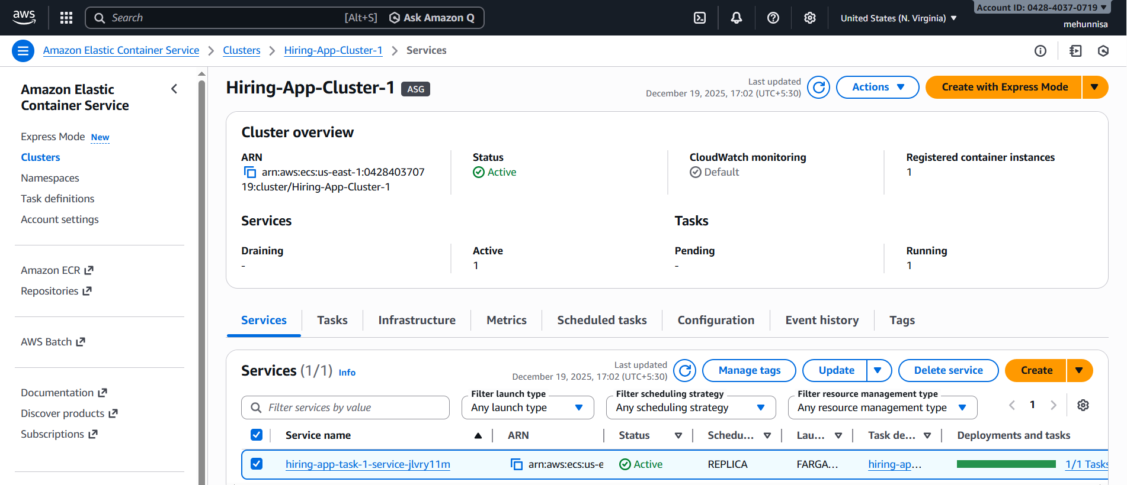
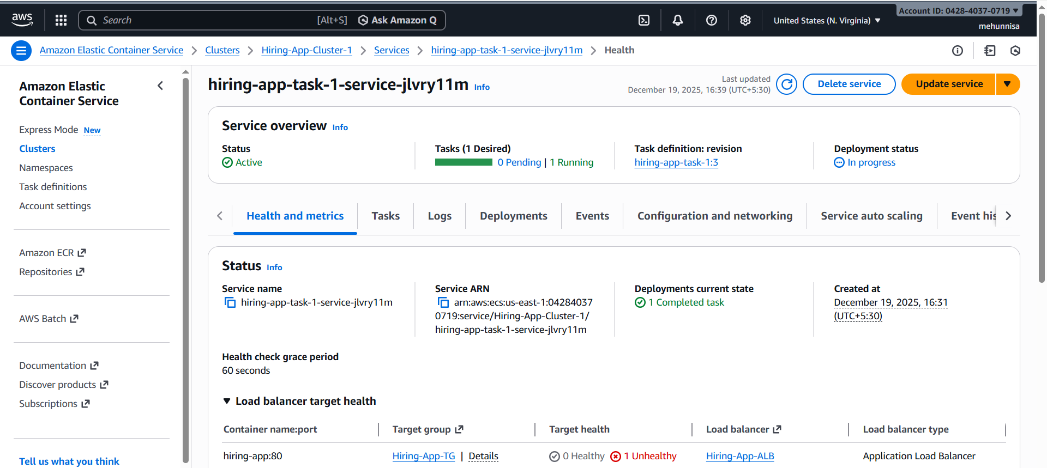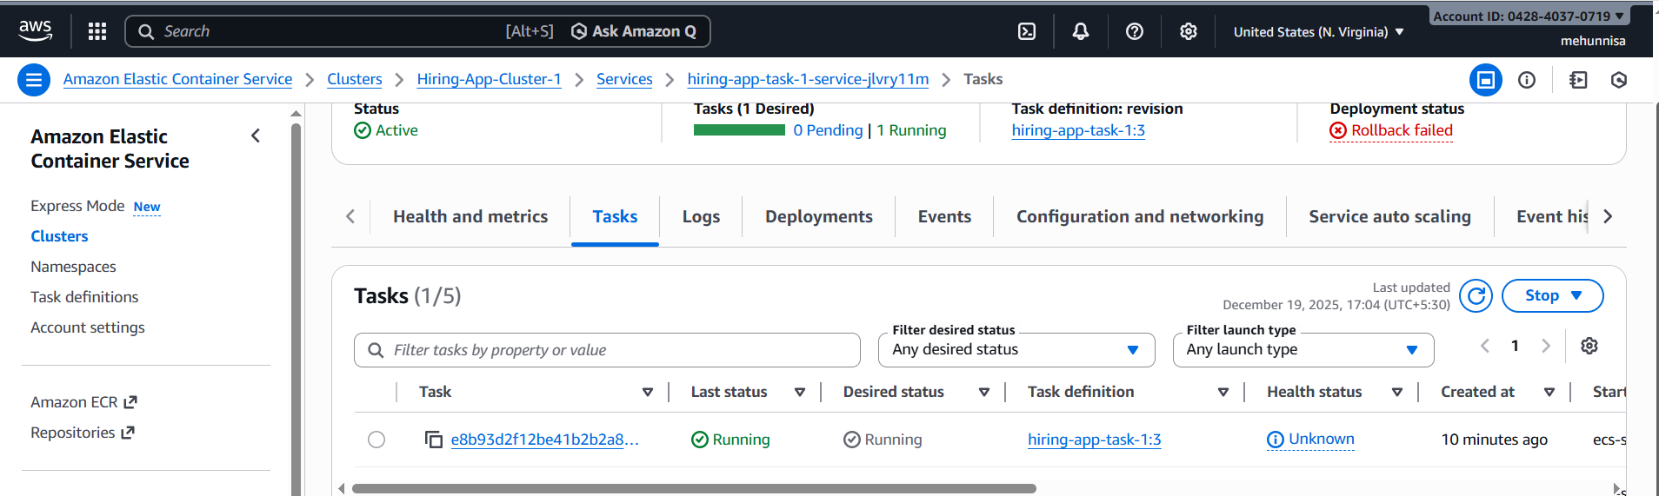
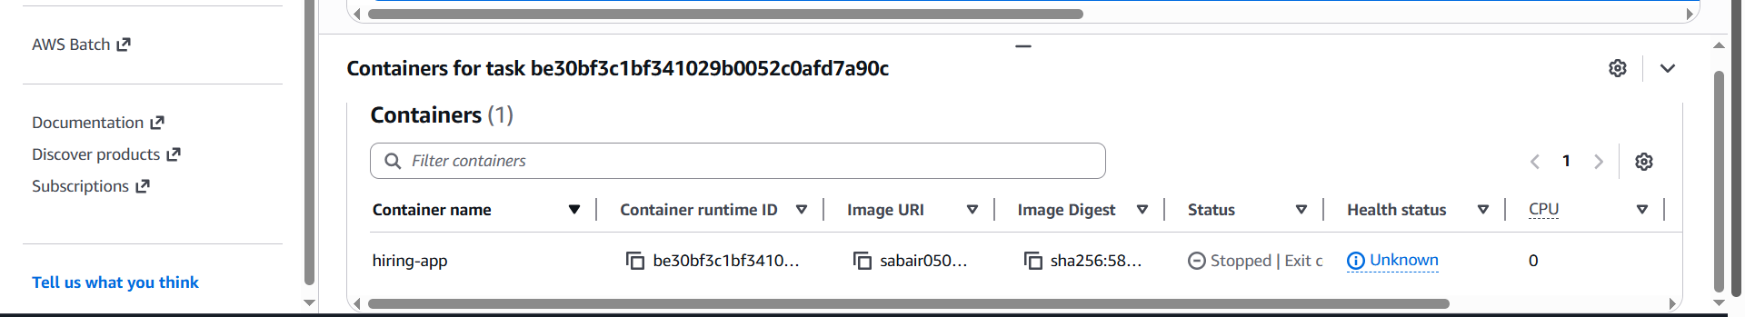
SSH into your ECS EC2 instance where the tasks are running.
We can find which EC2 instances are registered to the cluster in the ECS console → cluster → ECS instances.

Here , I have one container instances with instance type → t3.small
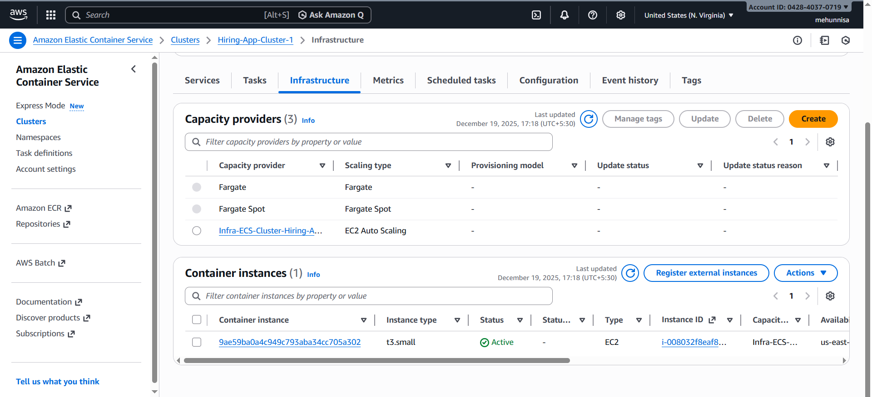now, Go to ec2 → click instances
Find the instances with :
- Instance type: t3.small
- Name/ ASG linked to ECS

Check the security group :
In instance details → security
Click on security group
If missing → Edit inbound rules:
Type: SSH
Port: 22
Source: [0.0.0.0/0]

Now connect using SSH:
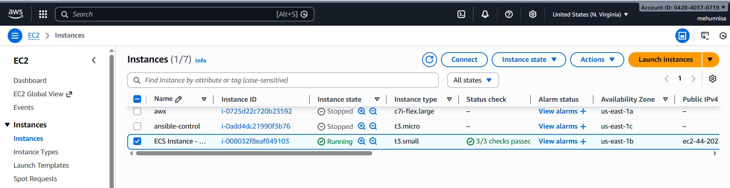
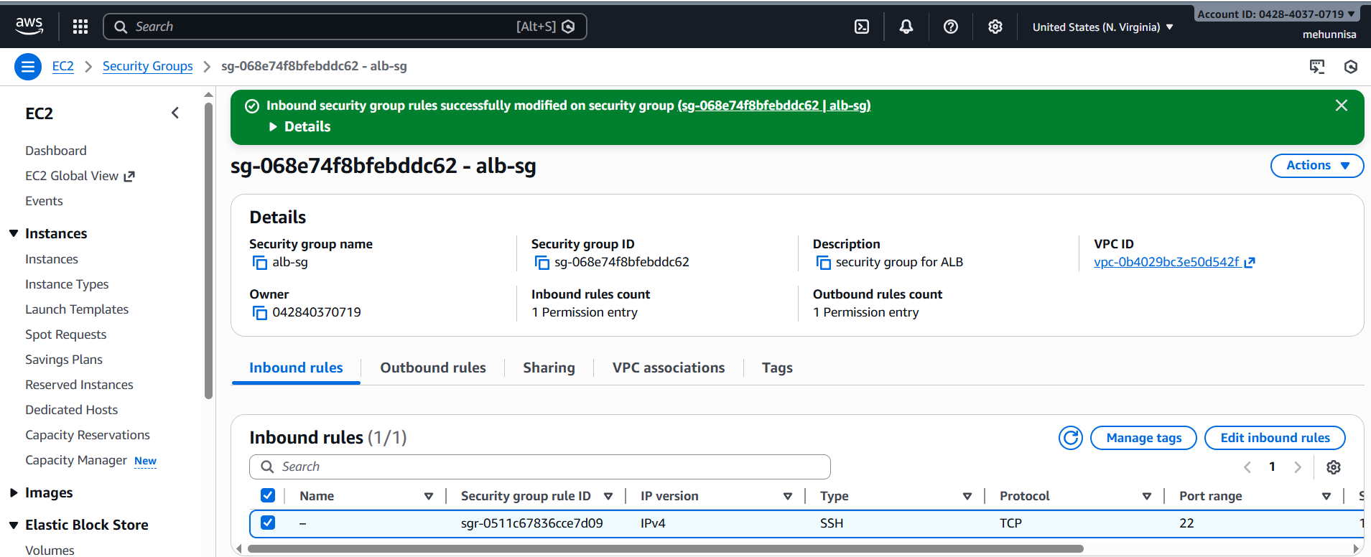
run docker ps on EC2 instances:
Docker ps
